Regulation Acceptance Testing (RAT)

Definition
# Source: AI Source: Provided by: [Data Path: Persons Table -> ID Column: 1, Name_En Column: Motasem Essam] -> From: [ChatGPT] on [8/23/2025]
Regulation Acceptance Testing (also called Regulatory Acceptance Testing) is performed to ensure that a software product complies with legal, regulatory, and industry-specific standards or guidelines mandated by governing authorities.
Failure to pass this testing can result in legal penalties, fines, or denial of product release.

Objective
# Source: AI Source: Provided by: [Data Path: Persons Table -> ID Column: 1, Name_En Column: Motasem Essam] -> From: [ChatGPT] on [8/23/2025]
- Verify that the system meets all applicable laws, regulations, and compliance requirements.
- Ensure the product is safe, secure, and legally approved for deployment in the target market.

When is it Performed?
# Source: AI Source: Provided by: [Data Path: Persons Table -> ID Column: 1, Name_En Column: Motasem Essam] -> From: [ChatGPT] on [8/23/2025]
- After System Testing and often before production release.
- In regulated industries like finance, healthcare, government, telecommunications, etc.

Who Performs It?
# Source: AI Source: Provided by: [Data Path: Persons Table -> ID Column: 1, Name_En Column: Motasem Essam] -> From: [ChatGPT] on [8/23/2025]
- Compliance teams and legal experts, sometimes along with QA teams.
- External regulatory authorities or certification bodies in some cases.

What Does It Cover?
# Source: AI Source: Provided by: [Data Path: Persons Table -> ID Column: 1, Name_En Column: Motasem Essam] -> From: [ChatGPT] on [8/23/2025]
- Data Protection & Privacy – e.g., GDPR, HIPAA compliance.
- Security Requirements – e.g., PCI-DSS for payment systems.
- Accessibility Standards – e.g., WCAG for web accessibility.
- Industry Regulations – e.g., FDA (healthcare), SOX (finance), FAA (aviation).

Examples
# Source: AI Source: Provided by: [Data Path: Persons Table -> ID Column: 1, Name_En Column: Motasem Essam] -> From: [ChatGPT] on [8/23/2025]
- A healthcare application tested for HIPAA compliance to protect patient data.
- A banking app tested against PCI-DSS for secure credit card transactions.
- An e-commerce platform verified for GDPR compliance regarding user data handling.

Advantages
# Source: AI Source: Provided by: [Data Path: Persons Table -> ID Column: 1, Name_En Column: Motasem Essam] -> From: [ChatGPT] on [8/23/2025]
✔ Prevents legal risks and penalties.
✔ Builds customer trust by ensuring compliance.
✔ Necessary for market approval in many regions.

Disadvantages
# Source: AI Source: Provided by: [Data Path: Persons Table -> ID Column: 1, Name_En Column: Motasem Essam] -> From: [ChatGPT] on [8/23/2025]
✘ Requires specialized legal and compliance expertise.
✘ Can be time-consuming due to regulatory audits.
✘ Expensive if external certification bodies are involved.

✅ Difference Between Regulatory Acceptance & Contract Acceptance
# Source: AI Source: Provided by: [Data Path: Persons Table -> ID Column: 1, Name_En Column: Motasem Essam] -> From: [ChatGPT] on [8/23/2025]
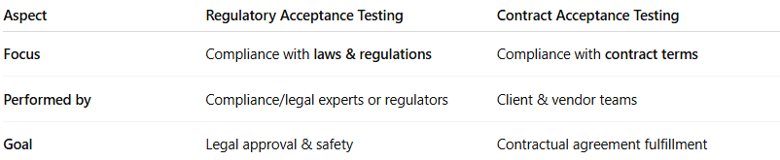
Aspect | Regulatory Acceptance Testing | Contract Acceptance Testing
Focus | Compliance with laws & regulations | Compliance with contract terms
Performed by | Compliance/legal experts or regulators | Client & vendor teams
Goal | Legal approval & safety | Contractual agreement fulfillment

